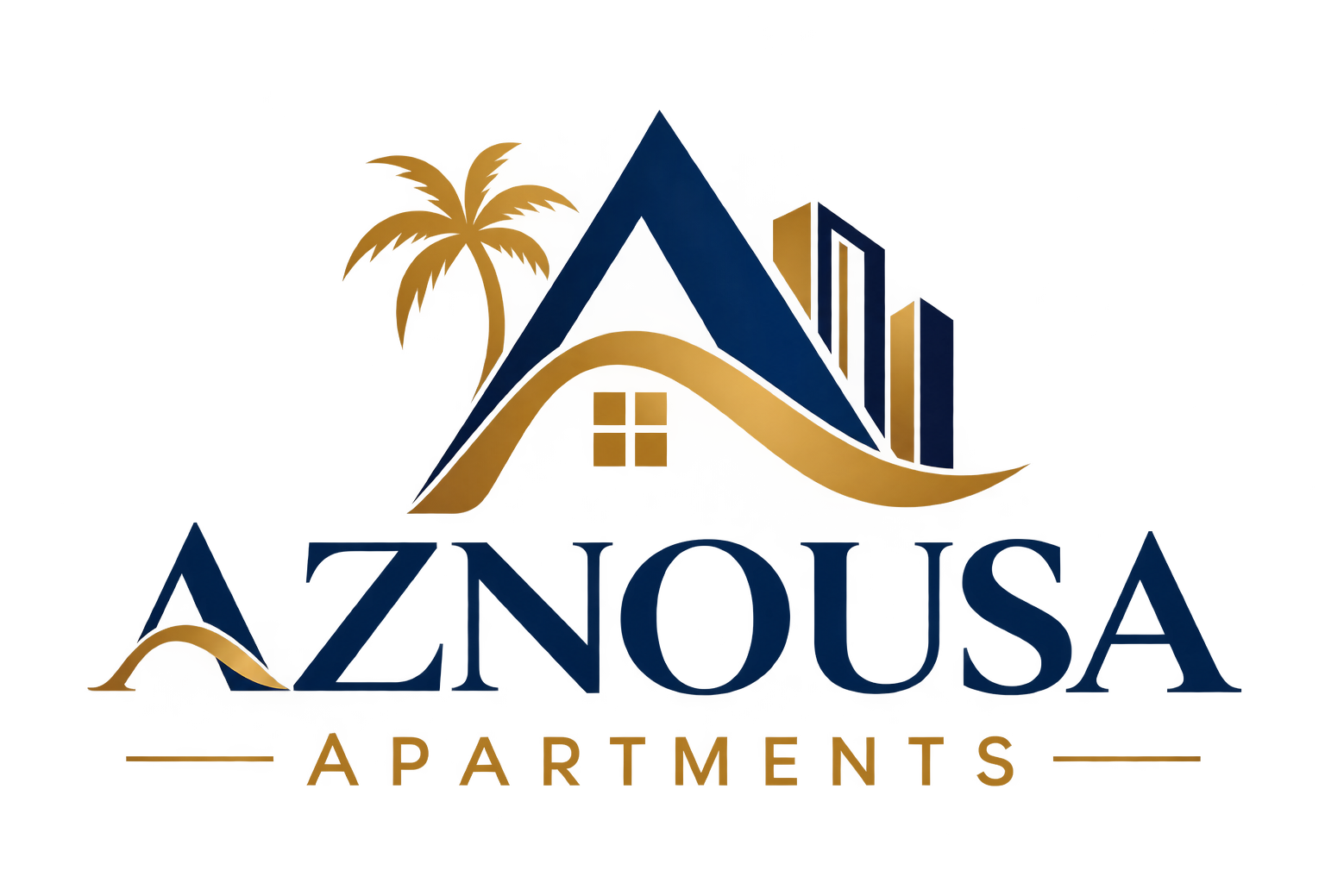
COMPANY PROFILE
Aznousa Apartments
Premium Furnished Housing for Corporate & Expat Teams in Paramaribo, Suriname
October 2026 · Prepared for corporate and institutional housing partners

1. Executive Summary
Aznousa Apartments is a Paramaribo-based provider of fully furnished, secured residential accommodation, purpose-positioned for the corporate, expat, and contractor housing needs created by Suriname's growing energy sector. The company currently operates six fully furnished units across two locations — a five-unit complex at Ramphalstraat (Bungalowpark) and a newly acquired unit on Nieuwe Grondweg, within close reach of Staatsolie's refinery and the Kuldipsingh Port Facility.
Aznousa Apartments is 100% Surinamese-owned and independently managed, with a single point of accountability for leasing, maintenance, and tenant support. The company is actively growing its portfolio under a deliberate “buy-and-build” strategy aimed at serving long-term corporate and institutional housing contracts as Suriname's offshore oil and gas sector expands.
At a glance
6 furnished units · 2 Paramaribo locations · 3-bedroom, fully furnished, gated & camera-secured · 100% Surinamese-owned sole proprietorship · Actively expanding portfolio · Registered with Suriname's Chamber of Commerce (KKF) and the Staatsolie SME Supplier Portal

2. Company Overview
Item | Detail
Trade name | Aznousa Apartments
Owner | Sabier Idoe
Legal form | Eenmanszaak (sole proprietorship), registered in Suriname
Registration | Registered with the Suriname Chamber of Commerce and Industry (KKF); registered on the Staatsolie SME Supplier Portal (smesupplierportal.sr)
Headquarters / operating location | Paramaribo, Suriname
Core business | Furnished residential rental for expats, oil & gas contractors, and corporate long-term housing contracts, plus short-stay accommodation
Portfolio | 6 fully furnished units across 2 locations (5 at Bungalowpark, 1 at Nieuwe Grondweg)
Business development & partnerships | Francisca Pawirodimedjo, consultant to Aznousa Apartments

The Bungalowpark property has a track record of housing tenants in Paramaribo, originally operating under the name “Kewalbansing Appartementen.” In 2026 the business was professionally rebranded as Aznousa Apartments under Sabier Idoe's ownership, with dedicated business development, marketing, and financial management support, and an active plan to expand the portfolio to meet growing corporate demand.

3. Our Portfolio
Aznousa Apartments currently operates two properties, totaling six fully furnished residential units:
Location | Address | Units | Configuration | Status
Bungalowpark | Ramphalstraat no. 29 (off Indira Gandhiweg), Paramaribo | 5 | 3-bedroom | Operational
Nieuwe Grondweg | Nieuwe Grondweg, Paramaribo (near the Staatsolie refinery and Kuldipsingh Port Facility) | 1 | 3-bedroom | Operational, move-in ready

All six units are of consistent 3-bedroom configuration today. Aznousa Apartments is actively expanding its portfolio and can evaluate sourcing or developing larger-format units (4-bedroom and above) to match the specific requirements of a multi-year corporate housing contract — see Section 9, Growth Trajectory.

4. Unit Specifications

4.1 Standard inclusions (every unit)
- 3 bedrooms, air-conditioned
- Private bathroom(s)
- Fully equipped kitchen (gas stove with oven, rice cooker, microwave, refrigerator)
- Washing machine
- Private balcony
- Private gate and driveway per unit
- Hot and cold running water
- Wi-Fi
- Security camera coverage
- Gated, fenced, and secured complex

4.2 Available by arrangement for corporate housing contracts
The following items are not part of the current standard unit specification but can be sourced and installed as part of a corporate housing agreement, scoped and priced against the tenant's requirements:
- Backup power generator, including maintenance, fuel, and refueling service
- Dishwasher, dryer, and coffeemaker
- Dedicated 24/7 on-site security personnel (in addition to existing camera coverage and gated access)
- Scheduled housekeeping (e.g., twice weekly)
- High-speed internet upgrades to meet a specified minimum bandwidth

A note on fit
We present our current offering honestly. Several items commonly required in institutional housing contracts (standby power, enhanced housekeeping, additional on-site security staffing) are not yet standard across the portfolio, but are readily arrangeable as part of a scoped corporate agreement. We would welcome the opportunity to review a specific scope of requirements and confirm exact fit, cost, and timeline.

5. Security & Safety
Both properties are gated and fenced, with security camera coverage and private, individually gated access per unit — features that are uncommon at this price point in the Paramaribo rental market and are a deliberate part of Aznousa Apartments' positioning for expat and corporate tenants. Dedicated 24/7 guard staffing and CCTV monitoring services can be added for a corporate contract requiring that level of coverage.

6. Strategic Locations

6.1 Bungalowpark
Located at Ramphalstraat no. 29, off the Indira Gandhiweg, within Paramaribo. A quiet, established residential side street with convenient access to the city's main arteries.

6.2 Nieuwe Grondweg
Acquired in 2026 specifically for its proximity to Suriname's energy-sector infrastructure: the Staatsolie refinery and the Kuldipsingh Port Facility, both central to offshore operations support (including the GranMorgu and Sloanea projects). This location directly shortens the commute for technical and contractor staff working at or near those facilities.
To confirm before submission
Exact driving distance/time from each property to the Assuria Highrise Building (central Paramaribo) should be confirmed and inserted here if this profile is used to respond to a requirement with a specific proximity threshold (e.g., within 25 minutes).

7. Why Partner With Aznousa Apartments
Local ownership: 100% Surinamese-owned and operated, with direct, local decision-making and accountability — no intermediary layers.
Security-first design: Gated complexes, individual unit access, and camera coverage as standard, at a price point below Paramaribo's premium-tier expat housing.
Single point of contact: One accountable owner-operator for leasing, maintenance, and tenant support, backed by dedicated business development and financial management.
Consistent quality: A uniform specification across all units simplifies planning and budgeting for multi-unit corporate bookings.
Responsive to corporate requirements: Willing and able to scope, price, and add contract-specific services (power backup, housekeeping, enhanced security) rather than offering a fixed, take-it-or-leave-it product.
Growth capacity: An active acquisition strategy means Aznousa Apartments can scale its portfolio over the life of a multi-year contract, not just at a single point in time.

8. Market Context: Suriname's Growing Energy Sector
Suriname's offshore oil and gas sector is entering a period of sustained growth. The GranMorgu project (Sapakara-Krabdagu, developed by Staatsolie, APA Corporation, and TotalEnergies) represents an investment of approximately USD 26 billion, with first oil expected in 2028. The Sloanea gas project (TotalEnergies / Petronas group) is expected to deliver first gas in 2030. Together, these represent two successive waves of foreign investment and workforce mobilization into the Paramaribo area.
This growth is driving sustained demand for quality, secure, furnished housing for expatriate staff and contractors — exactly the segment Aznousa Apartments is built to serve. Precise workforce numbers have not been publicly disclosed by operators, but the direction of demand is clear and well documented.

9. Growth Trajectory & Vision
Aznousa Apartments' ownership has articulated a clear growth strategy: to buy and build additional apartment properties, principally to serve the expat and corporate rental market. The 2026 acquisition of the Nieuwe Grondweg property — selected specifically for its proximity to energy-sector infrastructure — is the first concrete step in that strategy, not a one-off expansion.
For a corporate partner, this means Aznousa Apartments is positioned to grow its available inventory, including larger-format units, in step with a multi-year housing contract, rather than being limited to its present six units.

10. Qualification & Compliance Readiness
Aznousa Apartments is a locally registered, professionally managed small enterprise, and is building out the documentation and processes expected of institutional housing partners:
Qualification area | Current status
Administrative / legal | Registered as an eenmanszaak with Suriname's Chamber of Commerce (KKF). Equivalent registration and tax documentation can be compiled and provided in the format required by a given tender process.
Financial | Financial and contract management is handled with dedicated support (see Section 2), including a working financial model and monthly reporting discipline.
Social responsibility & local content | Surinamese-owned and operated; registered on the Staatsolie SME Supplier Portal, supporting local content objectives.
HSE / technical / anti-corruption | As a growing small enterprise, formal HSE, anti-corruption, and technical qualification documentation is being developed in line with what institutional partners require, and can be prioritized for a specific opportunity.

Note
Several formal tender-qualification documents (e.g., updated Articles of Association or equivalent, tax registration evidence, incident/accident history, named contact details) sit outside the scope of this company profile and should be compiled separately to match a specific tender's documentation checklist.

11. Contact
Name | Role | Phone | Email
Sabier Idoe | Owner | [Phone to confirm] | [Email to confirm]
Francisca Pawirodimedjo | Business Development & Partnerships | [Phone to confirm] | frannypawiro@gmail.com

Aznousa Apartments welcomes the opportunity to discuss a specific corporate housing requirement, provide a site visit, or submit further documentation in support of a qualification or tender process.

